Calling all activists, advocates, prisoners, ex-prisoners, their family and friends, as well as all others committed to the movement to expose and eradicate the prison industrial complex human rights violation
  - Seattle, WA
Local Organizing Committee
Amani Sawari, Local Representative
amanisawari@gmail.com
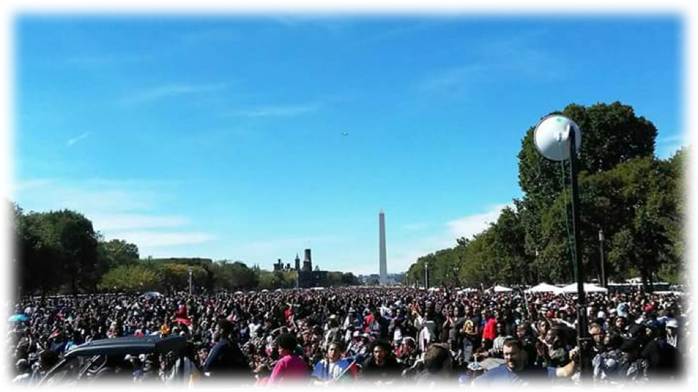
Twitter: @SawariMi
Email or direct message for more information about the Seattle local organizing committee to spread awareness, attend events, and participate in going to Washington D.C. for the historic Millions for Prisoners march

